

MATHEMATICS
METHODS

Test 5 –Differentiation and Applications of Differentiation
Chapters 2 and 3 Sadler
Semester 2 2015

Section One – Calculator Free
Time allowed for this section
Working time for this section: 20 minutes
Marks available: 17 marks
Materials required/recommended for this section
To be provided by the supervisor
This Question/Answer Booklet
Formula Sheet
To be provided by the student
Standard items: pens, pencils, pencil sharpener, eraser, correction fluid/tape, ruler, highlighters

Important note to candidates
No other items may be used in this section of the paper. It is your responsibility to ensure that you do not have any unauthorised notes or other items of a non-personal nature in the room. If you have any unauthorised material with you, hand it to the supervisor before reading any further. All working out must be shown for full marks to be awarded.
- (5 marks)
Sketch the graph of a function that satisfies all of the conditions below. You do not need to determine the equation of such a function.
- The function cuts the x axis at (-6,0), (-2,0) and (2,0)
- The gradient of the function is zero at x = -4 , x = 0 and x = 4
- The gradient is positive for x < -4, 0 < x < 4, x > 4
- The gradient is negative for -4 < x < 0
- The graph cuts the y axis at -5

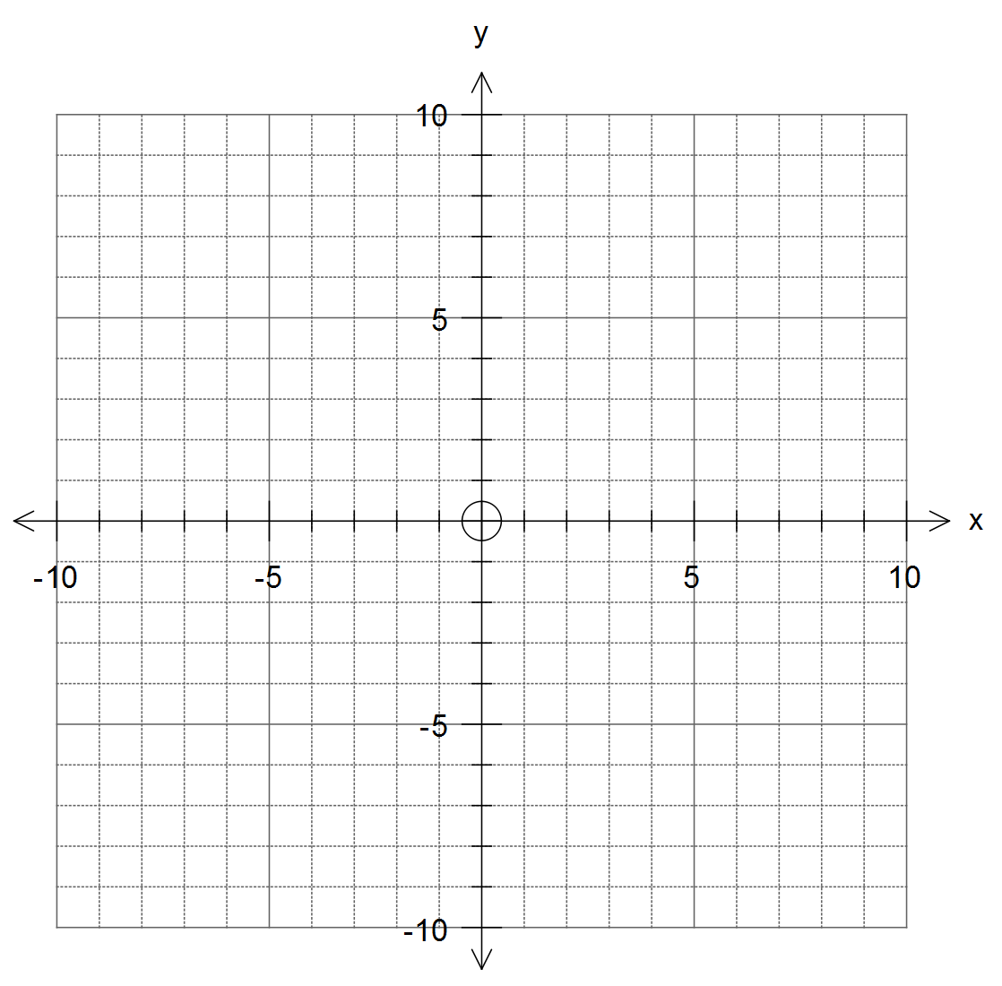

2. (8 marks)
Find the derivative of the following functions.
- y = 3x⁴ [1]

- y = 3x² – 2x + 5 [2]

- y = (2x² – x + 3)(4x – 5) [use the product rule for full marks] [3]

- 2y = 4x² + 6x - 8 [2]

- (4 marks)
Find the equation of the tangent to y = 3x² – x, at x = 3.

End of Section One

